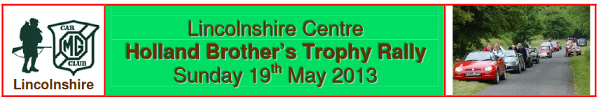

**Lincolnshire Centre**

**Holland Brothers Trophy Rally**

**Sunday 5th October, 2025**

1. Lincolnshire Centre of the MG Car Club will promote a Navigational Scatter Rally on Sunday 5th October, 2025.

2. An M.S.A. permit has been applied for.

3. The event is open to all fully elected members of the promoting club. Club membership cards will be inspected at signing-on. **Each entry requires a driver and a navigator to have a Motorsport UK RS Clubman Licence.**

4. The programme of the event will be as follows:- Arrive 9.15 a.m. coffee/tea bacon rolls available

Instructions will be handed out at 9.30 a.m. First car away at 10.30 a.m.

The event is not timed, and the rally should take approximately 3 hours.

5. This is a test of navigational skills. Use of GPS systems or any similar navigational aid is prohibited and will result in exclusion.

6. The winning team will receive the Holland Brothers Trophy which will be presented at a date and venue to be confirmed

7. The maximum number of entries is 12.

8. The entry list opens on 14th September, 2025 and closes on the day of the event

9. The entry fee is £16.00. All Cheques should be made payable to the “MG Car Club”, or paid direct to the Bank Account.

10. The Secretary of the event, to whom entries must be sent, is:- Ian Mackenzie

11. You will require:- OS Map 1:50,000 scale Landranger Series 130 Grantham & Surrounding Area

A Pencil and Eraser, A roamer or metric ruler, A navigator and a car with a working milometer

12. The START will be Leasingham Garden Centre, Moor Lane, Leasingham map ref. 057.5/484.

13. Coffee/tea and breakfast will be available at the start .

Lunch/Refreshments will be available after the event at Low Farm Park, Folkingham map ref. 071/334

(pre ordering for lunch is recommended)

**N.B. Personal data is collected by the Club to allow proper administration of this event**

ENTRY FORM - I wish to enter the Holland Brothers Trophy Rally on Sunday 5th October 2025.

Name . . . . . . . . . . . . . . . . . . . . . . . . . . . . . . . . . . . . . . . Membership Number: . . . . . . . . . . . . . . . . . . . . . .

Address . . . . . . . . . . . . . . . . . . . . . . . . . . . . . . . . . . . . . . . . . . . . . . . . . . . . . . . . . . . . . . . . . . . . . . . . . . . . . . . . . . . . . . . . . . . .

. . . . . . . . . . . . . . . . . . . . . . . . . . . . . . . . . Postcode . . . . . . . . . . . . . . . . . . . . . . . . . . . . Telephone . . . . . . . . . . . . . . . . . . . . .

Mobile Number . . . . . . . . . . . . . . . . . . . . . . . . . . . . . . .

My Navigator will be (member/non-member) ………………….………………………….. Email . . . . . . . . . . . . . . . .. . . . . . . . . . . . .

Car Make . . . . . . . . . . Model . . . . . . . . . . . . . . . . . . . . Year . . . . . . Registration Number . . . . . . . . . . . . . .

I have paid by bank transfer to:-

“MG Car Club”

Sort Code 30-95-05

Account No. 01202030 Reference Naviscat and your surname

or enclose a cheque payable to "MG Car Club"  
  
PLEASE SEND YOUR COMPLETED APPLICATION FORM TO – Ian Mackenzie,

69 Churchfields Road,

Folkingham,

Sleaford,

Lincs.,

NG34 0TR

or via Email to Treasurer@mgcclincolnshire.co.uk

Please let me know if you would like to order breakfast and or lunch

Breakfast Yes 1 or 2 No

Lunch Yes 1 or 2 No